Understanding lung cancer patients’ experiences
Insights from the Global Lung Cancer Coalition’s 2024 global patient experience survey
September 2024

Introduction

For the last five years, the Global Lung Cancer Coalition (GLCC) has run an annual global patient experience survey, gathering a wealth of useful data and insights on experiences of diagnosis, treatment, and care. We at the GLCC want to understand patients’ experiences of lung cancer and the barriers and challenges they face to inform our global and national campaigning priorities, and we conduct this survey yearly to ensure our ongoing activities and advocacy are reflective of current patient experiences, needs, and preferences.

This report sets out the global findings from our fourth annual global survey, which ran from 28 March 2024 to 14 May 2024 and received 905 responses from patients across 18 countries.

We are grateful to all the patients who took the time to share their experiences via the survey. We hope the findings will be useful to policymakers in their planning, as well as to campaigners advocating for lung cancer patients’ needs.
Key findings & common themes

As stated in our patient charter, the GLCC believes that every patient has the right to have access to quality health care; informed self-determination; physical and mental integrity; and confidentiality and privacy, and to be treated with dignity and respect.

Whilst each patient’s experience and preferences during their lung cancer journey are different, there are some common themes across varying geographies and health systems.

This year’s patient experience survey highlighted some encouraging trends including improved involvement score in treatment and care decisions (when compared to the 2023 results) and good support for patients who either chose not to pursue or have no treatment options available.

However, it was also clear from the survey results that more needs to be done to ensure patients get the information they need at the time that it is most useful to them. This is true across the patient journey, including for biomarker testing – where there is still significant confusion amongst patients despite relatively high levels of access to testing.

Methodology

For the GLCC’s fifth annual patient experience survey, the steering group drafted questions on a range of topics, including:

- Biomarker testing
- Palliative care
- Involvement in treatment and care
- Seeking information
- Help to cope

The Coalition commissioned Censuswide to conduct this global survey of lung cancer patients, with responding participants verified and enrolled to Censuswide’s network via direct recruitment. A series of 13 questions was included in the survey, with participants identified in each question by gender, age, and location.

The following countries were surveyed:

Argentina, Australia, Bulgaria, Canada, Denmark, Greece, Ireland, Israel, Italy, Japan, Mexico, Portugal, Netherlands, South Africa, Spain, Taiwan, UK, US

Demographics

Across the countries surveyed, 78% of respondents (704/905) were male, 21% of respondents (194/905) were female, and seven respondents identified as non-binary.

The age of respondents varied as follows:

- 16-24: 4
- 25-34: 13
- 35-44: 262
- 45-54: 179
- 55+: 447

43% had small cell lung cancer, and 93% had been diagnosed in the last five years.

While an important insight into the experiences of patients around the world, GLCC recognises the limitations of this polling. Respondents to this survey were disproportionally male and younger than the average person living with lung cancer. Additionally, the survey captured a greater proportion of people living with small cell lung cancer. For future surveys GLCC is exploring alternative methodologies to ensure a more representative sample.

Deeper Dive

Biomarker testing

Respondents with non-small cell lung cancer or those who do not know what type of cancer they have, were asked the following with regard to biomarker testing:

- Doctors can take a sample of a tumour to test for biomarkers (also known as mutation, genomic, or molecular testing). Has anybody spoken to you about this topic?

- If you were spoken to about biomarker testing, do you feel you understood what it is?

92% of eligible respondents (346/375) had been spoken to about biomarker testing, of which 69% (257/375) reported having a biomarker test [see Figure 1].

However, nearly 40% of respondents (129/346) didn’t understand what was meant by ‘biomarker testing’ when they first heard about it. One-third of respondents (32%, 110/346) did their own research to understand what biomarker testing was – illustrating the clear need for improved communication around the topic of biomarker testing, as well as reliable clear additional resources for people to access.

Key insight: As biomarker testing and personalised treatments become more available, eligible patients need to understand the role of biomarker testing in their treatment journey - good communication between treatment teams and patients will be essential.

Palliative care

Despite the majority of patients with lung cancer requiring supportive and palliative care in their care journey, research into these areas of care is often overlooked. To better understand patients’ experiences with palliative care, respondents were asked the following:

- If treatment was not available, or you chose not to undergo treatment, or haven’t started treatment yet, what happened next?

Of the 92 survey participants who responded to this question, 50% (46/92) were referred to palliative care, 40% (37/92) were referred to pain management, 45% (41/92) were referred back to primary care or their GP or family doctor, and 20% (18/92) stayed with their oncology team [see Figure 2]. Only one participant noted that nothing happened, showing a good level of support across the care journey.

Key insight: Although the terminology around non-treatment care often differs between countries, it is encouraging to see all but one participant had been offered support when either no treatment was available, or they chose not to undergo treatment.

Patients’ involvement in their treatment and care

The GLCC believes that every patient has the right to be fully informed of, and be involved in, decisions about their treatment and care. This right is enshrined in the GLCC’s Patient Charter.

As such, in this survey we wanted to understand the extent to which lung cancer patients feel involved in decisions made about their treatment and care, and the methods by which they prefer to communicate with their treatment team in various situations.

The following questions were asked of participants:

- When talking to your treatment team, did you feel involved in the decisions about your treatment and care?

- What do you think is the best way to have a conversation with your treatment team in the following situations?

98% of respondents (885/905) answered that they did feel involved in decisions about their treatment and care, and nearly half of respondents (48%, 438/905) answered that they had been fully involved – this is up from 91% and 34% respectively in 2023. A small group (2%, 20/905) did not feel involved in decisions about their treatment and care, with all but one of these respondents saying they would have liked to have been.

When asked about preferences around meeting with their treatment teams, most participants preferred face-to-face meetings in all situations throughout the care pathway. Telephone calls were respondents’ secondary preference in all situations, except for when finding out their diagnosis (where video was preferred) [see Figure 3].

Key insight: It is good to see such a large proportion of respondents feeling involved in their care and important for healthcare professionals to always look to ensure patients are as involved as they would like to be.

With regards to how patients wish to have conversations about their care, these findings highlight that despite changes in the availability of tele-health, patient preferences can vary, and treatment teams should take care to accommodate these preferences.

Seeking information

Alongside conversations with treatment teams, GLCC was keen to better understand patients’ experiences of seeking and receiving information about their condition. To this end, participants were asked:

- To accompany the discussions with your treatment team, what is your preferred format for receiving information about your condition?

- What best describes how you feel about the information you received from your treatment team about your lung cancer?

There was notable variation amongst country responses and ages with regards to the preferred format for receiving information. However, cancer support hotlines (33%, 297/905), print materials (29%, 261/905) and apps (14%, 128/905) all ranked highly [see Figure 4].

Across the course of the patient treatment and care pathway, the majority of patients reported receiving the right information at the right point. However, there was still a notable number of individuals at each point in the care journey who felt the information they received came too late [see Table 1]. This was especially problematic at the point of starting treatment when 9% (75/803) of respondents reported receiving the information regarding their care too late.

Table 1: What best describes how you feel about the information you received from your treatment team about your lung cancer?
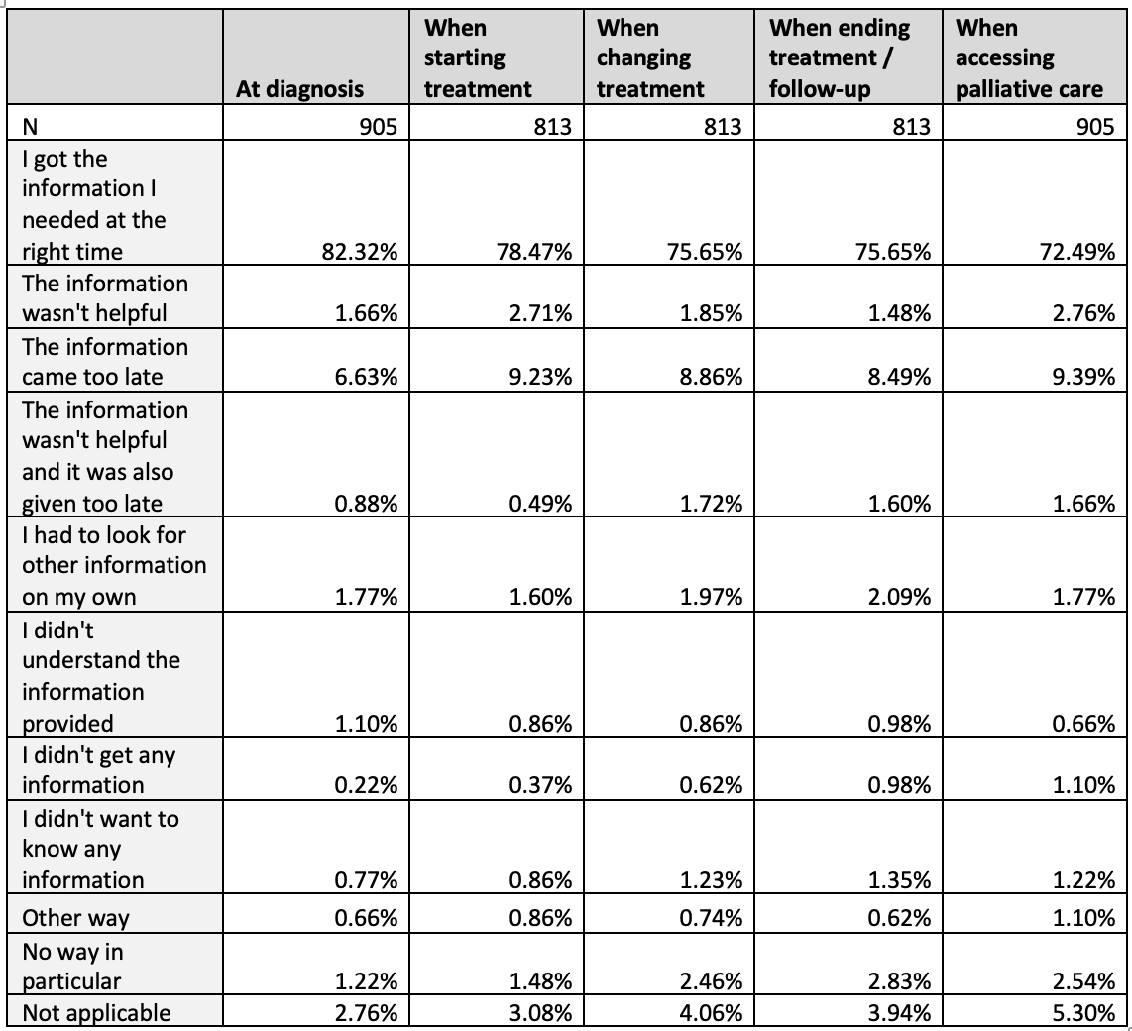

Key insight: The majority of patients report they received the right information at the
right time. However, there is still more to do on this, particularly as patients move through the care pathway. The data also serves as a helpful reminder that information should be
presented in several formats, as patients’ preferences vary.

Help to cope

As part of patients’ experience of care, GLCC sought to explore where patients receive support from and how this compares to where they would like to receive support. Participants were asked:

- Where do you get help to cope with your disease?
- Where would you like to get help to cope with your disease?

People receive support from a range of place, with healthcare professionals (67%, 602/905), family and friends (62%, 559/905), in-person support groups (29%, 258/905), online support groups (25%, 224/905), social media communities (21%, 190/905) and counselling/ therapy (19%, 172/905), all ranking highly.

Men and women differ in their use of social media communities (19% v. 28%), counselling/therapy (16% v. 28%) and peer matching services (15% v. 9%).
Likewise, respondents who were 55+ were the least likely to seek help through counselling (11%) when compared with the other age brackets [16-24: 50%; 25-34: 31%; 35-44: 25%; 45-54: 29%]

Respondents were also asked what support they would like to receive to help them cope. Answers were broadly aligned with what support is already being accessed, although there was a greater demand for counselling or therapy (23% v.19%), as well as a desire for greater support from spiritual or religious communities (11% v. 7%) and work colleagues (7% v. 4%).

Figure 5: Where do patients get help to cope with their disease compared to where they would like to get help from
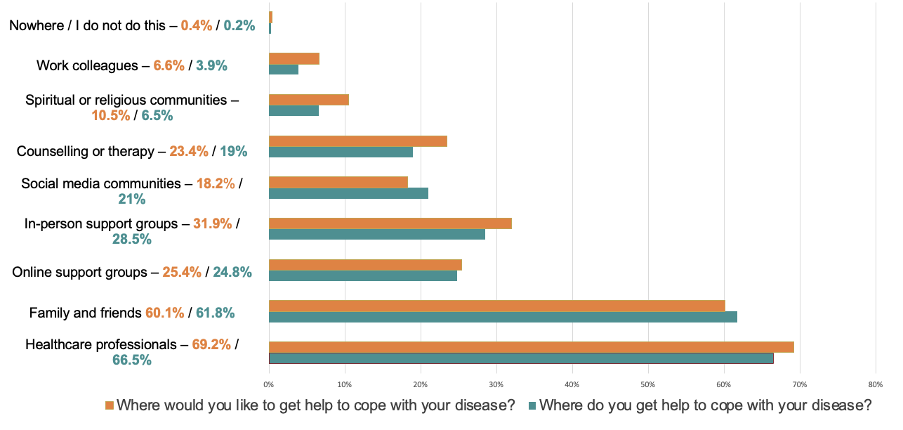

Key insight: Most patients rely on healthcare professionals for support in coping with their disease, but gaps remain in desired counselling or therapy (23% desired vs. 19% currently accessing). Patients’ support preferences varied by country/region, likely due to cultural differences, making it important to consider country-specific preferences and needs when shaping initiatives like patient support programmes.

More information

The Global Lung Cancer Coalition is an alliance of patient organisations from across the world. Established in 2001, the GLCC comprises 41 non-government organisations from 29 nations: Argentina, Australia, Brazil, Bulgaria, Canada, Czech Republic, Denmark, France, Germany, Greece, Hungary, Ireland, Israel, Italy, Japan, Mexico, Netherlands, Norway, Peru, Portugal, Slovenia, South Africa, Spain, Sweden, Switzerland, Taiwan, Turkey, UK, and US.

The GLCC promotes global understanding of lung cancer and the right of patients to effective early detection, better treatment, and supportive care. By serving as the international voice of lung cancer patients, the GLCC is committed to improving disease outcomes for all.

For more information about our 2024 survey, the findings from previous global patient experience surveys, or the work of the GLCC, please visit our website at www.lungcancercoalition.org or email our secretariat at: glcc@roycastle.org.

