Global briefing:
Symptom awareness, attitudes to lung cancer and views on screening
Findings from a global survey

Overview
The Global Lung Cancer Coalition (GLCC) is an alliance of patient organisations committed to increasing awareness and understanding of lung cancer and campaigning to improve lung cancer outcomes for all.

The GLCC’s Patient Charter asserts the right of all lung cancer patients to: be treated with dignity and respect; be free of blame and stigma for having the disease and to have their disease de- stigmatised; have access to quality health care; informed self-determination; physical and mental integrity; and confidentiality and privacy.

In 2023, the GLCC commissioned its fourth multi-national study to understand attitudes towards lung cancer, levels of symptom awareness among the public and views on
The GLCC is calling on governments and health systems across the world to:
- Increase recognition of lung cancer symptoms through targeted public awareness campaigns
- Improve public education and understanding of lung cancer and its causes to reduce stigma
- Highlight the importance of early diagnosis and treatment in improving survival to encourage more people to seek help early
- Implement national lung cancer screening programme to help people get diagnosed and into treatment as early as possible
lung cancer screening.The study was undertaken in 29 countries: Argentina, Australia, Brazil, Bulgaria, Canada, Czech Republic, Denmark, Egypt, France, Germany, Great Britain, Greece, Italy, Israel, Japan, Mexico, Netherlands, Norway, Peru, Portugal, Republic of Ireland, Slovenia, South Africa, Spain, Sweden, Switzerland,Taiwan,Turkey and USA. Responses were received from at least 1,000 adults per country.

The study looked to build on the findings from previous studies conducted in 2010, 2013, and 2017, which can be found on the GLCC website.

Key findings

Symptom recognition
- Nearly four out of ten people (37.5%) said they did not know any symptoms of lung cancer
- Men were more likely to report not knowing any symptoms compared to women (40.49% vs. 34.85%)
- People aged 18-24 were most likely to report not knowing any symptoms (45.11%)
- People who had never smoked were more likely to report not to know any symptoms than people who currently smoke
/have smoked in the past (40.20% vs. 36.65%)
- There was significant variation between countries, with the percentages of people who indicated they did not know any symptoms ranging from 16.80% in South Africa to 54.36% in Japan

Attitudes towards lung cancer
- Over four out of ten people (42.62%) agreed with the statement ‘I have less sympathy for people with lung cancer than other types of cancer’
- Men had less sympathy for people with lung cancer than women (50.38% vs. 35.67%)
- Sympathy increased with age, with nearly 50% of 18-24 year olds agreeing they had less sympathy for people with lung cancer
- People who currently smoked/had previously smoked were slightly less sympathetic than people who had never smoked (43.15% vs. 42.33%)

Views on lung cancer screening
- Over eight out of ten people agreed there should be a national lung cancer screening programme to help people with lung cancer get diagnosed early (84.89%)
- Men and women showed nearly equal supported the need for lung cancer screening programmes (84.12% vs. 85.57%)
- Support grew with age, increasing from 78.65% of 18-24 year-olds to 86.01% of people aged 55 and over
- While both largely supportive, people who currently smoke/had previously smoked were even more supportive than people who had never smoked (86.78% vs. 82.48%)

Methodology
The GLCC commissioned the market research agency Censuswide to undertake an online survey of adults across 29 countries between 3 July 2023 – 6 July 2023.The survey samples included at least 1,000 adults
(per country) and data was weighted using age, gender and region to produce a representative sample in each country. Respondents were asked the following questions:

- Q1.There are many warning signs and symptoms of lung cancer. Please list as many symptoms of lung cancer as you can think of [a tick box was provided for ‘Don’t know’]
- Q2. Lung cancer is mainly caused by smoking cigarettes and other tobacco products.To what extent do you agree or disagree with the following statement: I have less sympathy for people with lung cancer than for other types of cancer
- Q3.To what extent do you agree or disagree with the following statement:There should be a national lung cancer screening programme to help people with lung cancer get diagnosed early

Further analysis

Symptom recognition
Raising awareness of lung cancer symptoms is vital because treatment is more likely to be successful if lung cancer is diagnosed early.

The study found that symptom awareness is generally poor, with nearly four out of ten people (37.5%) saying they did not know any symptoms of lung cancer.There was large variation across countries, but surprisingly, not a large difference by smoking status.

The findings of the survey suggest far more work needs to be done to support greater awareness of lung cancer
symptoms.

Chart 1. Percentage of respondents who indicated they did not know any symptoms, by country

South Africa | 16.80%
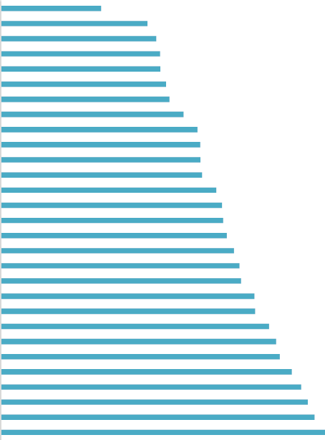  Peru |  |  |  | 24.56%
UK |  |  |  | 26.01%
Turkey |  |  |  | 26.65%
Australia |  |  |  | 26.68%
Portugal |  |  |  | 27.67%
Republic of Ireland |  |  |  | 28.24%
Netherlands |  |  |  | 30.58%
Canada |  |  |  | 32.90%
Taiwan |  |  |  | 33.37%
Mexico |  |  |  | 33.43%
Sweden |  |  |  | 33.70%
Norway |  |  |  | 36.06%
USA |  |  |  | 37.01%
Argentina |  |  |  | 37.22%
Greece |  |  |  | 37.81%
Egypt |  |  |  | 39.03%
Spain |  |  |  | 39.95%
Slovenia |  |  |  | 40.22%
Brazil |  |  |  | 42.42%
Germany |  |  |  | 42.56%
Switzerland |  |  |  | 44.90%
France |  |  |  | 46.08%
Denmark |  |  |  | 46.70%
Italy |  |  |  | 48.70%
Israel |  |  |  | 50.25%
Czech Republic |  |  |  | 51.38%
Bulgaria |  |  |  | 52.50%
Japan |  |  |  | 54.36%
0% |  | 10% | 20% | 30% | 40% | 50% | 60%

Chart 2. Percentage of respondents who indicated they did not know any symptoms, by age

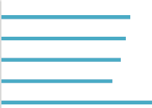  55+ | 38.44%
45-54 | 37.12%
35-44 | 35.64%
25-34 | 33.16%
18-24 | 45.11%
0% 10% 20% 30% 40% 50%

Chart 3. Percentage of respondents who indicated they did not know any symptoms, by smoking status

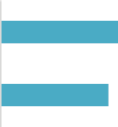
I've never smoked 40.20%

I currently smoke/used to
smoke
36.65%

0% 10% 20% 30% 40% 50%

Attitudes towards lung cancer
More than eight out of ten cases of lung cancer are linked to smoking, creating stigma around the disease. This is a problem not only because thousands of people develop lung cancer who have never smoked, but also because people who have smoked may feel guilty and delay talking to their doctor about potential symptoms.

The GLCC believes that everyone – no matter what the cause of their cancer – deserves to have high quality treatment and care. No one deserves to have lung cancer, and if lung cancer can be picked up early, it improves people’s chance of successful treatment and survival.

To understand attitudes to lung cancer, participants were told that: “Lung cancer is mainly caused by smoking cigarettes and other tobacco products”.They were then asked whether or not they have less sympathy for people with lung cancer than other types of cancer.

Nearly four out of ten people agreed that they had less sympathy for people with lung cancer, with men and younger participants having less sympathy than women and older participants respectively.This represents a significant increase from the 2017 polling, which found 21% of respondents reported having less sympathy.

There was also significant variation between countries in the proportion of adults who have less sympathy for people with lung cancer, with responses ranging from 31.77% of participants agreeing with the statement in Norway to 79.35% agreeing in Egypt.
Chart 4. Percentage of respondents who agree with the statement they have less sympathy for people with lung cancer than for other types of cancer, by country
31.77%
32.51%
33.12%
33.37%
35.69%
35.93%
36.01%
36.56%
37.23%
37.95%
39.81%
39.84%
39.92%
40.25%
40.30%

Norway | 31.77%
Sweden | 32.51%
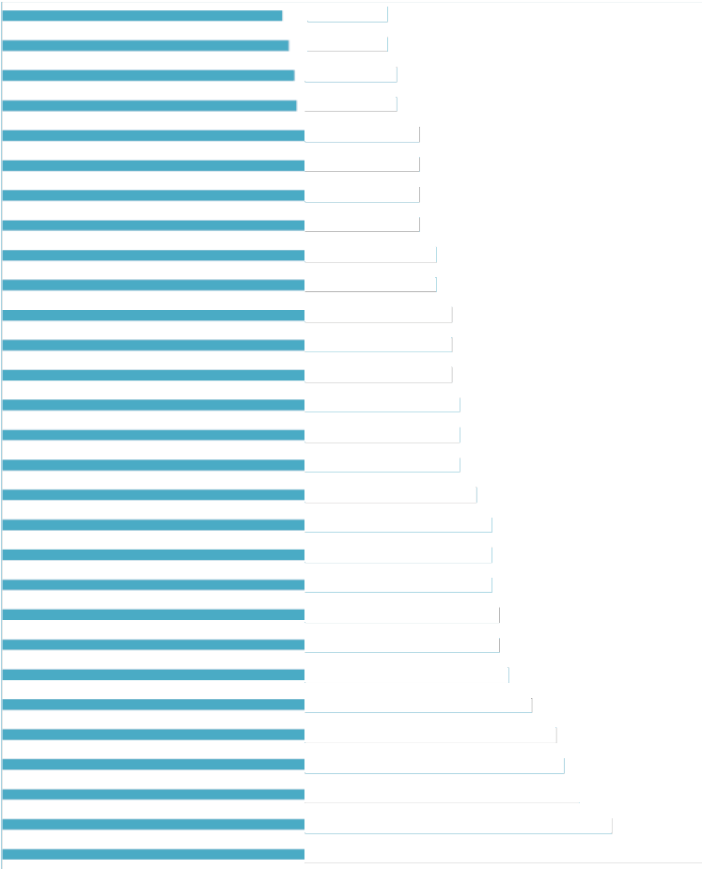  Spain | 33.12%
Netherlands | 33.37%
Canada | 35.69%
Portugal | 35.93%
France | 36.01%
Australia | 36.56%
UK | 37.23%
Brazil | 37.95%
Argentina | 39.81%
Mexico | 39.84%
Republic of Ireland | 39.92%
Japan | 40.25%
Germany | 40.30%
Greece | 40.50%
Denmark | 41.70%
Slovenia | 43.01%
Peru | 43.88%
USA | 43.98%
Italy | 44.27%
Switzerland | 44.40%
Bulgaria | 45.21%
South Africa | 48.44%
Israel | 50.75%
Czech Republic | 51.47%
Turkey | 53.60%
Taiwan | 57.24%
Egypt |  | 79.35%

0% 10% 20% 30% 40% 50% 60% 70% 80% 90%
40.50%
41.70%
43.01%
43.88%
43.98%
44.27%
44.40%
45.21%
48.44%
50.75%
51.47%
53.60%
57.24%

Chart 5. Percentage of respondents who agree with the statement they have less sympathy for people with lung cancer than for other types of cancer by age

55+
45-54
35-44
25-34
18-24
30.65%

37.12%
43.01%
45.86%
48.17%

0% 10% 20% 30% 40% 50%

Chart 6. Percentage of respondents who agree with the statement they have less sympathy for people with lung cancer than for other types of cancer, by


I've never smoked

I currently smoke/used to smoke
42.33%

43.15%

0% 10% 20% 30% 40% 50%

Views on lung cancer screening
A national lung cancer screening programme is a key measure to reduce the substantial burden that the disease currently imposes on the individuals affected, their families, and the country and healthcare system as a whole.

Lung cancer screening with a non-invasive scan of the lungs (low-dose computed tomography [LDCT]) can save lives by detecting the disease at an early stage when it is potentially curable. A large clinical trial of LDCT screening showed a 24% reduction in lung cancer mortality in men and a 33% reduction in women at 10 years of follow-up compared to no screening (de Koning 2020).

This survey found that there is broad global support for national lung cancer screening programmes, with eight out of ten people agreeing there should be a national lung cancer screening programme in their country.While support grew with age and people who currently smoke/had previously smoked were even more supportive than people who had not smoked (see charts 8 & 9 respectively), it is encouraging that there is such wide support.

77.38%
79.76%
80.04%
81.22%
81.36%
82.12
83.45
84.18
85.8
86.
86.
87.
87.
88
8
9
9
9
9
9
9
At present only a few countries have national lung cancer screening programmes. Given the impact they can have and the support for them globally, the GLCC calls on policymakers around the world to implement national lung cancer screening programmes to help people with lung cancer get diagnosed as early as possible.

Chart 7. Percentage of respondents who agree there should be a national lung cancer screening programme to help people with lung cancer get diagnosed early, by country
66.21%
71.90%
72.01%
72.60%
76.48%

  Japan | 66.21%
Denmark | 71.90%
Netherlands | 72.01%
Switzerland | 72.60%
Sweden | 76.48%
France | 77.38%
Czech Republic | 79.76%
Slovenia | 80.04%
Norway | 81.22%
Canada | 81.36%
Israel | 82.12%
Germany | 83.45%
USA | 84.1 %
Italy | 85.85%
Taiwan | 86.51%
UK | 86.62%
Spain | 87.08%
Australia | 87.85%
Republic of Ireland | 88.82%
Bulgaria | 89.92%
Brazil | 90.62%
Greece | 91.34%
Argentina | 91.58%
Mexico | 3.10%
Portugal | 3.18%
Peru | 3.20%
Turkey | 93.97%
South Africa | 95.31%
Egypt | 96.34%
0% | 10% 20% 30% 40% 50% 60% 70% 80% 90% 100%

Chart 8. Percentage of respondents who agree there should be a national lung cancer screening programme to help people with lung cancer get diagnosed early, by age

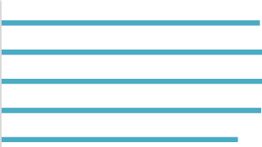  55+ | 86.01%
45-54 | 86.92%
35-44 | 86.91%
25-34 | 86.36%
18-24 | 78.65%

0% 20% 40% 60% 80% 100%

Chart 9. Percentage of respondents who agree there should be a national lung cancer screening programme to help people with lung cancer get diagnosed early, by smoking status

I've never smoked

I currently smoke/used to smoke
82.48%


86.78%

0% 20% 40% 60% 80% 100%

More information
Established in 2001, the GLCC comprises 43 non-government patient organisations from Argentina, Australia, Brazil, Bulgaria, Canada, Czech Republic, Denmark, Egypt, France, Germany, Greece, Ireland, Israel, Italy, Japan, Mexico, Netherlands, Norway, Peru, Portugal, Russia, Slovenia, South Africa, Spain, Sweden, Switzerland,Taiwan, Turkey, UK and US.

The GLCC promotes global understanding of lung cancer and the right of patients to effective early detection, better treatment and supportive care. By serving as the international voice of lung cancer patients, the GLCC is committed to improving disease outcomes for all.

For more information about this study and the work of the GLCC please visit: www.lungcancercoalition.org or email our secretariat at: glcc@roycastle.org.

